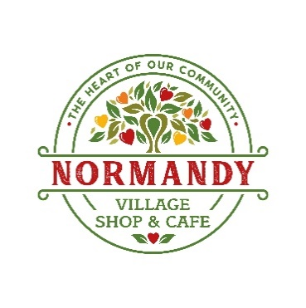
VOLUNTEER APPLICATION FORM
NORMANDY COMMUNITY SHOP & CAFE

Volunteers are required to complete this application form, attend an induction session and, if preparing, handling or serving food, must complete a Food Hygiene Certificate course (this is a simple course completed online and is paid for by the Normandy Shop & Cafe). All volunteers will have access to the Normandy Shop & Cafe’s health and safety statement, risk assessment and policies on equal opportunities and protection of children, young people and vulnerable adults. ALL INFORMATION PROVIDED IN THIS FORM WILL BE TREATED CONFIDENTIALLY.

PERSONAL DETAILS
Full name (Ms, Mrs, Mr, Miss, Dr, other – add as appropriate
Address (incl post code)
AGE GROUP (please tick or circle one) | 16 - 30 | 30 - 50 | 60 - 70 |  | Over 70 | Emergency Contact’s name
Telephone  (land line) |  |  |  |  |  | Relationship to you
Mobile No |  |  |  |  |  | Telephone  (land line)
Email |  |  |  |  |  |  | Mobile
Can your own telephone number(s) be made available to other staff and volunteers in the shop? |  |  |  |  |  |  |  |  |  | YES | NO

By supplying your telephone number and email address you are giving us permission to contact you by
telephone and email which reduces our costs. We never share your details with any third party.

APPLICATION INFORMATION
Is there a specific Volunteer Role you wish to apply for? If yes, please specify the role

AVAILABILITY – at what times are you available for volunteering? Please enter the times that are convenient for you. | AM | PM
example | 8.00 am – 11.00 am | 1.00 pm – 3.00 pm
Monday
Tuesday
Wednesday
Thursday
Friday
Saturday
Sunday

Why do you want to become a volunteer for the Normandy Shop & Cafe?

Have you done any voluntary work before? Please give details
Do you have any skills, qualifications, experience, hobbies or interests that you think might be relevant?

Do you have any health issues, disabilities or additional support needs that we should be aware of? Advising us of this will allow us to respond correctly should there ever be an accident or emergency situation you are involved in while volunteering in the Normandy Shop & Cafe.

Reference details
Referee name
Address (incl post code)
Telephone number
Relationship with Referee

Declaration

The personal information I have given in this application is correct and complete to the best of my knowledge and belief.

Signature _____________________________________________ Date __________________________

PLEASE DO NOT COMPLETE THIS SECTION, IT IS FOR OFFICE USE ONLY - THANK YOU
Received application (date)
Date contacted |  |  |  | Date interviewed
References requested |  |  | YES/NO
If applicable, outcome of references
Date approved |  |  |  | Starting date

